# Conflict Scenario

## **Review**

### Interpersonal Conflict Management Styles

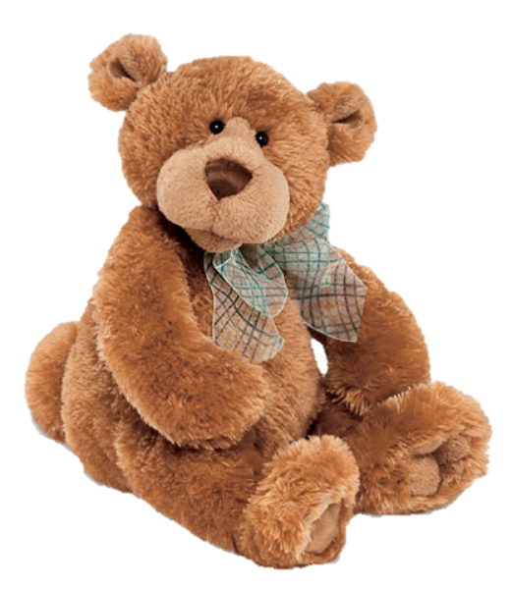

[CC 2.0 BY Matthew](https://www.flickr.com/photos/falcon1961/3304306800/)



[CC SA 3.0 Unported BY Jonathan Zander](https://en.wikipedia.org/wiki/File:Florida_Box_Turtle_Digon3.jpg)



[CC 3.0 BY Superawesomevectors](https://superawesomevectors.deviantart.com/art/Shark-Cartoon-Free-Vector-Illustration-643399222)



[CC0](https://pixabay.com/en/urban-lost-hiding-afraid-1002149/)

Low to High Concern for Other

Concern for Self



CC SA 2.0 Generic BY [Carine06 from UK](https://commons.wikimedia.org/wiki/File:Flickr_-_Carine06_-_%22I_give_up.%22.jpg)



CC 2.0 BY [Zabara Alexander](https://www.flickr.com/photos/zabara_tango/6955720271)

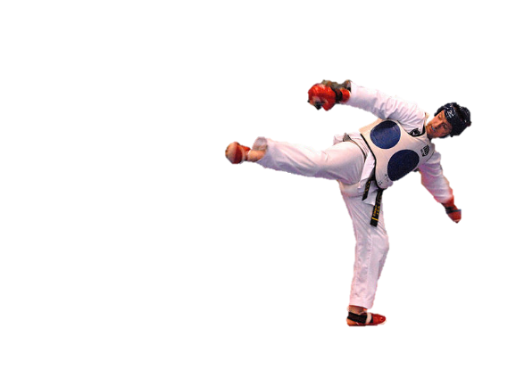

[CC0](https://commons.wikimedia.org/wiki/File:US_Army_53525_Soldiers_compete_in_Tae_Kwon_Do_tournament_for_Warrior_Country_level.jpg)

### **Interpersonal Conflict Resolution**

The following diagram shows a process that can be followed when trying to resolve interpersonal conflict.

### Listening

A considerable proportion of our communication involves listening, yet little attention is devoted to improving listening. HURIER is an acronym for tips that can be used to improve listening.

### “I” Phrases for Conflict Resolution

The “I” phrase is used during conflict resolutions to avoid attacking others. Open the conversation with a statement in first person, passive voice: “I feel … when … because … I would like …”

Adapted from (Dwyer 2012, p. 40)

## **Student Name and ID:** Thomas Wust 12175215

## **Student Name and ID:** Kerri 12174360

## **Scenario**

Find a partner. Read the scenario below. Choose one partner to be Joe Bloggs, and the other to be Jane Doe. Together, answer the following to help prepare you for the role play.

## **Scenario: Joe did not complete a task by the deadline**

Joe and Jane are working on a report that is due today. Joe was assigned the task of writing the executive summary. Unfortunately, Joe has not completed the task.

What is the most appropriate conflict management strategy for Jane to use in this situation? (Choose one)

Compete/Force

Compromise

Avoid/Withdraw

Collaborate/Confront

Accommodate/Smooth

Why did you choose the above conflict management strategy?

Collaborate/Confront is a strategy that can fit within the time constraints while still achieving our desired result.

### **Listen and Understand**

How could Jane start the conversation?

Approaching the conversation with curiosity and no ill intention.

Questioning the delay with

“How’s the report going?”

“Is everything alright with the report?”

Describe the purpose of the discussion. Describe the conflict. What questions could Jane ask to determine Joe’s perspective of the situation?

Joe is defensive due to not meeting the deadline.

Trying to find a root cause for the delay in the report.

” Did something happen today/this week?”

” How are you feeling?”

” Is there something you would like to talk about?”

Write sentences that features the “I” phrase, such as in the example below:

“I feel *[your feeling]* when *[their behaviour]* because *[effects on you]*. I would like *[alternative behaviour]*”.

“I feel letdown when you do not complete your section of the report because it reflects poorly on us both. I would like better communication in the future to avoid this conflict if possible.”

Invent a reason why Joe did not complete the executive summary by the deadline.

The family had fallen ill with Covid, due to conflicting priorities Joe was unable to meet the deadline.

How could Jane paraphrase Joe’s reason for missing the deadline to ensure that she understands Joe’s perspective?

I understand Joe had larger priorities due to family health.

### **Empathise**

Now that Jane understands Joe’s perspective, how could Jane empathise with Joe? Write a response that shows that Jane identifies with Joe’s emotions.

“I understand your family has been unwell, I can see you’re frustrated. I hope your family is better and are on the mend and that you will finally be able to get some rest soon.”

### **Apologise**

Include an apology if it is appropriate.

Joe: I am sorry Jane that I let you down, I will try to better myself for future projects.

Jane: I apologise for having to pry into your personal life, I only wanted to help you if possible.

### **Offer Solution**

What question could Jane ask to help build Joe’s involvement with potential solutions?

” Is there something in the Executive Summary that you are struggling with or will struggle with? Is there something I can help you with?”

Come up with a way for Jane and Joe to settle on a solution.

Jane could offer help to Joe by supplying resources and/or terminology.

### **Resolution**

How could Jane resolve the conflict? Jane needs to ensure that Joe agrees. Write a response that outlines appreciation for the solution.

Jane could offer resources, terminology and have Joe agree to reconvene in an hour to identify progress.

### **Reconciliation**

How could Joe reconcile the relationship and let Jane know that she is important to him?

Thanking Jane for her consideration towards Joe’s situation and her hard work is greatly appreciated. Or treating her to a drink/meal.

How can Jane let Joe know she is listening while Joe is talking?

Nodding, leaning forward, resting hand on face not resting face on hand. Verbally acknowledging with questions and paraphrasing.

What could Jane do if Joe started to withdraw from the conflict at any stage?

Jane could advise Joe to cool down and that walking away from the situation could result in serious repercussions.